TimeSprite

Status Reports and Project Submissions

Date: 08/10/2015 to 15/10/2015

University of the Pacific

COMP 188, Senior Project, 2015 Fall ---Yunpeng Zhang

Contents

2 Project Schedule 2

3 Currents Status 3

3.1 Finished Tasks 3

3.2 Falling being schedule 3

4 Plan for next work period 4

4.1 Task for next work period 4

5 Challenges and concerns 5

6 updated artifacts 6

# Project Schedule

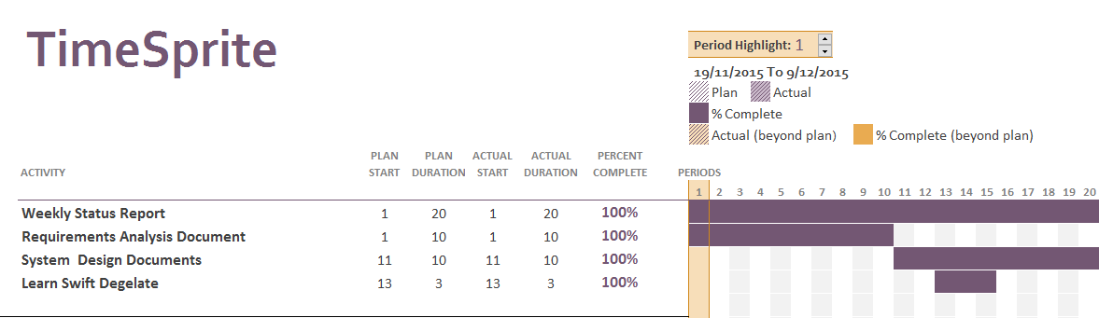

# Currents Status

## Finished Tasks

* Finished System Requirement document
* Finished Requirements Analysis Document
* Learn Swift
* Impalement basic class

## Falling being schedule

# Plan for next work period

## Task for next work period

* Implement all code

# Challenges and concerns

* All design documents has been finished, next step is following the documents to implement program.

# updated artifacts

* Include all documents, all gantt chart for this semester, and all weekly status report.